AM 310 – Instrumentation and Theory
of Experiments

Filter and Op Amp Circuitry

CONCEPTS: RC Filter, Op Amp, Frequency response, Phase response, Amplitude response, Gain, Attenuation, 3dB point, Distortion, Circuit gain, Differential amplifier.

- Introduction

When using transducers to make experimental measurements the signal they produce is often too small or too noisy to be detected by multimeters or oscilloscopes. To solve the former, amplifiers can be inserted into the measurement circuit. To solve the latter, frequency filters can be used. In this lab you will work with one type amplifier, called an operational amplifier (or op amp for short), and one type of filter called an RC filter (‘RC’ stands for resistor-capacitor).

By using appropriate resistors in combination with the op amp, you can build circuits that can amplify signals so that they can be detected by measuring equipment. The amplifier you will build in this lab (with an op-amp and two resistors) multiplies the signal at its input and provides this multiplied signal at its output. By arranging several op amps and other electronic components in the correct manner, signals can also be added, subtracted, and divided (as well as other operations). This is where the name for the component came from – it performs mathematical operations on the signal at its input.

The filter you will study is called a low-pass filter. It only allows signals below a certain frequency, called the cutoff frequency, to pass through the circuit. The cutoff frequency can be tuned by choosing appropriate values of the resistor and capacitor. Another type of filter, called a high-pass filter can be constructed simply by reversing the components of a low pass filter. Placing a low-pass filter and a high-pass filter in series results in a band-pass or band-reject filter, depending on the order of the filters.

- Theory

  - Filters

Electronic filters are used to attenuate components of an input signal in specific ranges of frequencies to eliminate unwanted parts of a signal and/or noise. Simple filters can be made using resistors and capacitors. The simple RC filter network is used extensively in electronic circuits. Therefore, it is useful to examine its input-output characteristics. Most often the input-output characteristics as a function of frequency are of major interest. That is, the ratio of the output voltage to the input voltage as a function of frequency (called the frequency or amplitude response) and the phase angle between input and output as a function of the frequency (called the phase response) are important. A simple low-pass filter circuit is shown in Figure 1.
R
C
~
v_{i}
v_{o}
Figure 1: A simple low-pass filter.

Ideally, low-pass filters allow signals with frequencies below a cutoff frequency to pass through unchanged and block signals with higher frequencies. Unfortunately, for real filters, like the one diagrammed above, the frequency response is more complicated than that – there is not a sharp cut off in frequency, but a more gradual one as shown in Figure 2. The plot was generated by applying A.C. network analysis to the RC circuit.

It is usual practice to think of the filter having a certain “gain” which varies with frequency. The gain of a filter is the ratio of the output voltage amplitude to the input voltage amplitude. For filters it is also called “attenuation.” If a filter’s input signal is a pure sinusoid of form E_{i}sin (ωt), the filter’s output signal will have the form E_{o} sin (ωt + φ). The gain is E_{o}/E_{i} and the phase shift is φ. The frequency response is E_{o}/E_{i} as a function of ω and the phase response is φ as a function of ω. An ideal low-pass filter would have E_{o}/E_{i}=1 for ω<ω_{cutoff} and E_{o}/E_{i} = 0 for ω>ω_{cutoff}, and φ =0 at all frequencies.

As mentioned above, a real filter has a more complicated response; for example a low pass filter has frequency response give by Equation 1 and phase response given by Equation 2. Equations 1 and 2 are plotted in Figure 2 as a function of frequency.
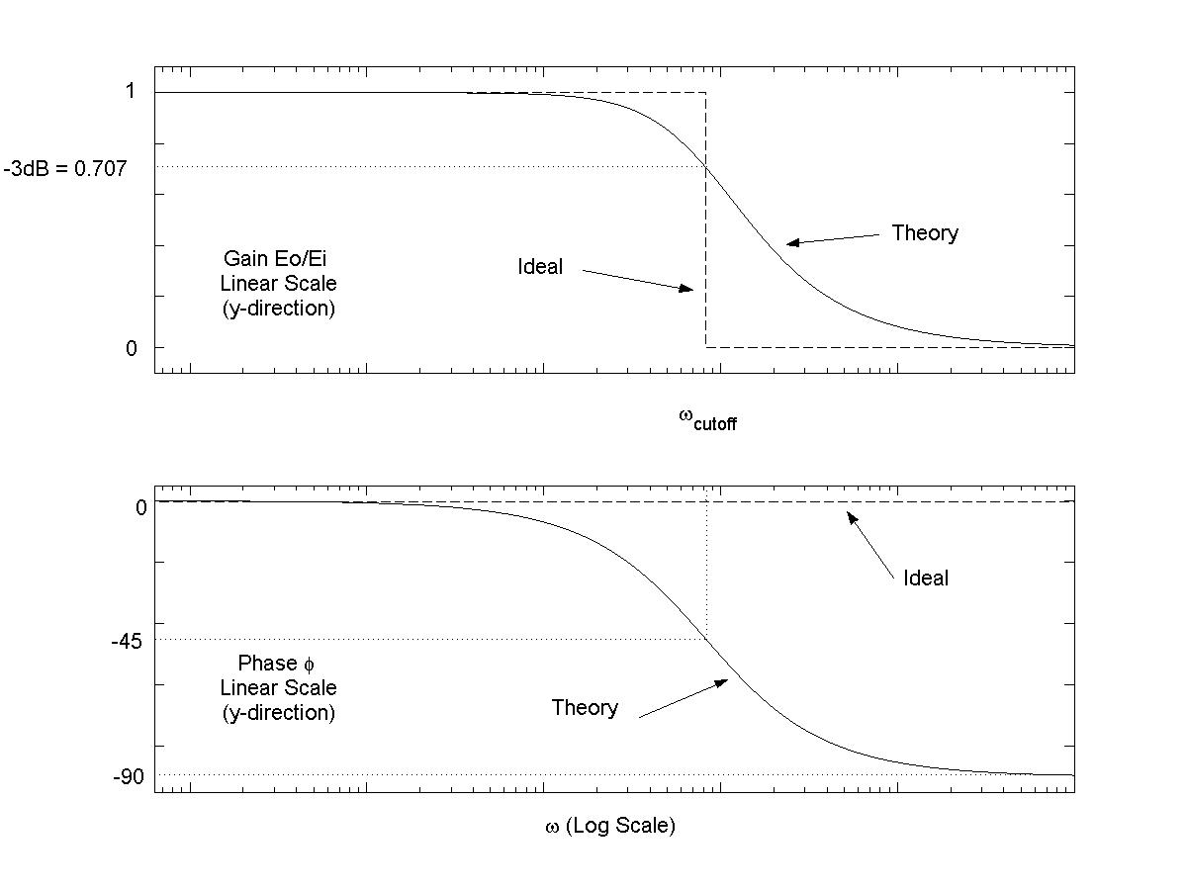
Figure 2: Frequency (top) and phase response (bottom) of a simple low-pass filter. Theory in the figure refers to the response calculated using A.C. network analysis

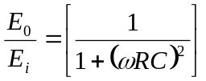 (1)
and
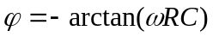 (2)

You should derive these two expressions as part of your prelab.

One parameter that characterizes low-pass filters is the 3dB point, which is defined as the frequency at which the attenuation E_{o}/E_{i} = -3dB = .707.

It should be noted that this circuit is a first order linear system so that the gain (E_{o}/E_{i}) can also be considered the amplitude magnification ratio (M), since the static sensitivity is unity, i.e., no change for DC signals.

  - Operational Amplifier

Nearly every field of modern science and technology depends heavily upon electronic instruments for the generation, processing, and recording of electrical signals representing particular physical variables. In designing modern instrumentation systems, one of the most versatile and widely used building blocks is the operational amplifier. An op amp is basically a small electronic device which amplifies small voltage signals by a large factor, over a wide frequency bandwidth, without drawing too much current from the signal source.

An op amp is, itself, a complicated “integrated circuit” (IC) containing many resistors, capacitors, and transistors or other semi-conductor devices, in a miniature package such as an 8 pin dual-in-line package (DIP) about ½ by ¼ by 1/8 inches in size. However, it is not necessary to know and understand the complex circuit of the op amp itself in order to use them. Only a few external connections are needed, and only a few properties of the op amp need to be known for effective instrument design.

    - Characteristics of Op Amps

The standard symbol for an ideal operational amplifier is shown in Figure 3. The chief property of the ideal operational amplifier is that its voltage output e_{o}, at any instant, is the difference between the voltages applied to its two inputs e_{p} and e_{n} times a constant (called the raw gain, A).

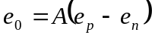 (3)

It is characteristic of operational amplifier that the raw gain A is usually very large. Common values range from tens of thousands to millions.
-
+
e_{n}
e_{p}
-
+
-
+
e_{o}
_
+
A
Figure 3: Symbol for high-gain operational amplifier

A is frequency dependent, i.e. the amount of gain provided by the op amp at one frequency is not the same as the gain provided at another frequency. Inspecting the specification sheets for the op amps (which for your convenience are provided the end of this lab write-up) you can see the behavior of A with frequency: at low and moderate frequencies, A is roughly constant, while at high frequencies, A decreases monotonically.

Another important characteristic of op amps is that the input resistance at both input terminals is very large. Common values range from a few hundred thousand Ohms to 10¹⁴Ω. This implies that the amplifier itself is essentially a voltage controlled device, that is, the input terminals draw only negligibly little current from the input signal source.

    - Basic Principles of Op Amp Circuits
_
+
A
-
+
e_{i}
+
i_{i}
-
e_{o}
e_{p} = 0
i_{n} = 0
SP
R_{f}
R_{i}
i_{f}
e_{n}
Figure 4: Simple operational amplifier circuit – an inverting amplifier

Precision measurements demand that the voltage gain of an amplifier be known very accurately. It is a relatively easy task for an electronics engineer to provide a large gain A. It is a difficult task to provide a very accurate gain which does not change with changes in ambient temperatures, power supply voltages, age of components, etc. One way to solve this problem is shown in Figure 4. The basic technique illustrated in Figure 4 trades a very large raw gain A whose actual value is difficult to control for a smaller (but still adequate) circuit gain which is accurate and stable. The technique is based on the application of negative feedback. In the figure R_{i} stands for input resistor and R_{f} stands for feedback resistor. The circuit is known as an inverting amplifier, because in addition amplifying the input signal, the sign of the voltage is reversed, so the output appears inverted compared to the input.

In the basic circuit in Figure 4, the output voltage e_{o} is determined by the op amp negative input e_{n} (the op amp positive input e_{p} is connected to ground so that e_{p} ≡ 0).

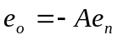 (4)

The high-gain input, e_{n}, is taken from the junction between resistors R_{i} and R_{f} connected to the overall input and output (e_{i} and e_{o} respectively). Hence, e_{n} is some linear combination of e_{i} and e_{o}. The junction is called the summing point, marked SP in Figure 4.

The value of e_{n} can easily be calculated. Because of the very high op amp input resistance, as mentioned above, the op amp input current i_{n} = 0. Thus Kirchoff’s node law applied to the summing point gives:

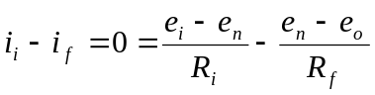 (5)
and solving for e_{n}, we find that

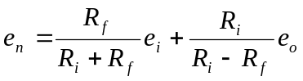 (6)

Now recall that the raw gain A of the op amp is very large (for example, a million). Thus by Equation 4:

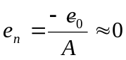 (7)

That is, in comparison to the size of e_{o}, e_{n} is very small, and may therefore be considered effectively zero (for this reason, the summing point, SP, is effectively at ground potential, and is called a “virtual earth”). Thus the left-hand side of Equation 6 is approximately zero, and the approximate amplification of the over all circuit is:

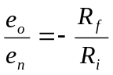 (8)

Which is simply the feedback resistor to input resistor ratio.

The exact value of the over all gain, obtained by substituting Equation 4 into Equation 6, is:

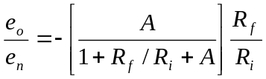 (9)

For A >> 1 + R_{f} / R_{i}, the quantity in brackets above becomes unity, and we obtain the formula in (8). The overall gain in thus virtually independent of the raw gain A as long as A is very large. By using the precision resistors R_{i} and R_{f} we obtain a precision amplifier with imprecise, and possible varying values of A.

More elaborate operational amplifier circuits are usually obtained by using other circuit elements in place of R_{i} and R_{f}. Let us call these elements Z_{i} and Z_{f} as shown in Figure 5. The discussion above shows that an elementary analysis of such circuits may be carriesd out very simply by use of the following principles:

Principle 1: Because of the large op amp raw gain A, the summing point voltage is always essentially zero: e_{n} = 0. (This is true only if e_{p} is tied to ground, otherwise e_{n} = e_{p}). Thus the inputs current i_{i} is determined simply by e_{i} and Z_{i}. (In the above example, Figure 5, i_{i} = e_{i}/Z_{i}. If e_{p} does not equal zero, i_{i} = (e_{i}-e_{p} /Z_{i})).

Principle 2: Because of the high op amp input resistance, i_{n} = 0. Hence, in the example above, Figure 5, the same amount of current flows through Z_{f} and Z_{i}: i_{f} = i_{i}. (In Figure 5, e_{o} = - Z_{f}i_{f} = - Z_{f}i_{i} = (Z_{f}/Z_{i})e_{i}).

_
+
A
-
+
e_{i}
+
i_{i}
-
e_{o}
e_{p} = 0
i_{n} = 0
SP
Z_{f}
Z_{i}
i_{f}
e_{n}

Figure 5: General operational amplifier circuit

- Experimental Procedure

  - Filter

The TF will give you the RC-circuit you built during the first lab period. For this section of the lab you will measure its amplitude and phase response as a function of frequency. If this procedure sounds familiar, it should. This is exactly what you did during the first lab when working with the RC circuit. The only difference is that this time, you will take more data points (i.e. measure the gain and phase at more frequencies) and you will have a choice to make when deciding how to measure the voltages in and out of the low-pass filter. You can either take data exactly the same way as you did for the previous lab, or use the multimeter to take the voltage amplitude measurements. Regardless of which method you choose, you will still have to measure the phase with the oscilloscope. If you choose to use the multimeter, remember it has inputs on both the front and the back. You can make use of both of them to avoid the annoyance of having to switch cables over and over again.

Connect the circuit to the source (the function generator) and to the measuring equipment (the oscilloscope and/or the multimeter) so that you can measure the phase and amplitude response. Use the wiring diagram from the first lab as a guide, if you need to. Or, if you thought ahead enough to make a detailed sketch of the set up last week, use your notes.

SPOT CHECK: Compare the theoretical and experimental value of the cutoff frequency and phase shift (φ) at the 3 dB point. Compute the theoretical value using Equations 1 and 2. Be sure to use the measured values for R and C in this calculation. To find the measured value, adjust the frequency until the ratio of the input to output voltage is .707.

Measure the amplitude and phase shift of the output for the following frequencies (in Hz) 20, 50, 100, 200, 500, 1000, 2k, 5k, 10k, 20k, 50k and 100k. Be sure that the input voltage remains at 10 volts peak-to-peak.

  - Op Amp

    - Linear Inverting Amplifier

Construct the circuit shown in Figure 4 (and in more detail in Figure 6). Observe the following precautions carefully:

1. Be sure power supply “COMMON” is tied to “GROUND.”

2. Do not raise the power supply voltage beyond ± 15 volts.

3. Do not apply input signals when power supply is off.

4. Turn off power when making changes in your circuit

5. Do not short op amp output to ground.

6. Use short leads.

7. Make sure port 4 on the op amp has a voltage potential of -15 volts with respect to ground and port 7 has a +15 volts potential with respect to ground

When building the circuit, try to use a single ground, e.g. the power supply ground. All voltages in the circuit will then be measured with respect to this common ground node, which is approximately 0 V.

Before powering your circuit, make sure to get it checked by the TF.

1
2
3
4
8
7
6
5
+15 Volts
Output
(+)
(-)
-15 Volts
Input
(+)
(-)
100KΩ
1MΩ
Figure 6: Wiring diagram of amplifier

Set up the inverting amplifier for a gain of 10 (R_{i} = 100 kΩ, R_{i} = 1MΩ). Set the function generator to the sinewave output with a frequency of 100Hz and adjust the amplitude so that it is 1 V peak-to-peak (as measured on the oscilloscope). Connect the function generator to the amplifier circuit and also to one channel of the oscilloscope. Connect the amplifier output to the other channel of the oscilloscope.

Set the oscilloscope for DC coupling and zero out any DC offset in the function generator output signal. An appreciable DC offset going into the amplifier can saturate it.

Measure the frequency response and phase response of the inverting amplifier for frequencies in the range from 100Hz to 1MHz.

Set the frequency to 1kH and increase the input signal to 4 V peak-to-peak. What does the output signal look like – what is this called?

    - Two-Stage Differential Amplifier

You will be given a breadboard with the circuit shown in Figure 7 already built. Check that the two stage amplifier is correctly wired and set up for two step gains of 10 (R₁ = 100 kΩ, R₂ = 1MΩ). Construct the voltage divider circuit shown in Figure 8 using the bread board that the amplifier is on. Connect the output of the voltage divider circuit to the input of your differential amplifier.

+
-
+
-
R₁
R₂
R₂
R₁
R₂
R₁
v_{o}
v_{i}
Figure 7: Two stage differential amplifier

Figure 8: Voltage divider. The numbers refer to the pins on the 3-pin potentiometers that will be used in the lab
1
3
2
+
-
-
+
[Battery]
1.5 V

Observe the output for the zero volt input case (i.e. with the battery disconnected). This output is a result of the DC offsets of the op amps. This bias will be added into every output of the amplifier. The voltage offset bias cold be adjusted and nulled out (called balancing the amp). However, since it is a constant shift for all input signals, which can be corrected for in the analysis of your data, and because the amplifier balancing circuit would add to the experimental complexity, you do not need to balance the amplifier.

Monitor the input and output voltages of the two stage amplifier and use them to calculate the gain for DC input voltages of 0, 0.0005, 0.01, 0.05 and 0.1 V. The input voltage is controlled by the voltage divider – turn the screw head on the potentiometer to change the input voltage. If the output signal is very noisy, it is possible that the potentiometer in your voltage circuit is at fault; try a different one.

NOTE: You will need the two-stage differential amplifier for your next lab. Do not dismantle it. Label it with your group number and give it to the TF. Also, include its operating characteristics (e.g. gain vs. input voltage and D.C. offset) in the prelab for the next experiment.

- Results

  - Filter

1. From the filter data, calculate the gain (i.e. E_{o}/E_{n}) of the filter and plot the gain as a function of frequency on log-log axes. Also calculate the phase angle variation with frequency and plot on log-linear axes (with frequency on the log axis).

2. Calculate the gain and phase angle variation for the low-pass filter from theory (using measured values of R and C). Plot the results of this calculation on the corresponding plots from 1.

3. Discuss your experimental results and compare with theory.

  - Op Amp

1. For the inverting op amp part, plot the measured gain as a function of the input frequency.

2. Derive the expressions for the gain from theory for an ideal op amp (A → ∞, Equation 8) and for a non-ideal op amp (A < ∞, Equation 9) and compare the theoretical results with those in the experiment. Remember, the specification sheets for the op amp being used in the lab can be found at the end of this write-up. By referring to Figure 3 on the specification sheet and to Equation 9 in the theory section, you should be able to compute the theoretical response of your op amp circuit. Add the theoretical and ideal response of the op amp to the plot from part 1.

3. Discuss the results you see. What is the operating range of the inverting amplifier for which gain can be independent of frequency?

4. Plot the phase shift of the signal as a function of input frequency. How does the phase shift vary between input and output for an ideal inverting amplifier? Is this what you observed in your measurements?

- Additional Reading

Dally, James W., William F. Riley, and Kenneth G. McConnell. Instrumentation for
Engineering Measurements. 2nd ed. John Wiley & Sons, 1992. Pgs: 60-65, 139-160.

Beckwith, Thomas G., N. Lewis Buck, and Roy D. Marangoni. Mechanical
Measurements. Reading, Massachusetts: Addison-Wesley, 1982. Pgs: 222-229, 158-185, 147-156.

Holman, Jack P. Experimental Methods for Engineers New York: McGraw-Hill, 1971.
Pgs: 141-145, 129-137, 117-127.

Figliola, Richard S. and Donald E. Beasley. Theory and Design for Mechanical
Measurements. 2nd ed. New York: Wiley, 1995. Sections 6.7 and 6.8.

- Authors

Written, revised and borrowed from Dr. Mort Isaacson
Dr. Bala Bharadvaj, Dr. Herb Voigt and Mr. Frank Kuhn (Feb. 1985
Revised by Dr. Mort Isaacson and Mr. Mike D’Angelo (Jan. 1987)
Revised by Dr. Mort Isaacson and Mr. Sam Bogan (Sept. 1991)
Revised by Dr. Mort Isaacson (April and Dec. 1992)
Revised by Mr. C. Thomas and Dr. R.G. Holt (May 2003)

Remember that the multimeter measures RMS voltage, not peak to peak.

